Required Test Scenarios

Assumptions
Limitation
Basic mixed workload
Quantum sensitivity case
Short-job-heavy case
Interactive-style fairness case
Validation case
Technically Correct Conclusions

Assumptions

- Context Switch Overhead is Zero
- CPU-Bound Processes Only
- Single-Processor Environment
- Tie-Breaking Rule
- Infinite Memory Available

Limitation

- Time unit only integers
- UI Scaling limits for Gantt Charts with huge processes
- Static Process Entry
- Basic UI & UX

Basic mixed workload

Write-up
We Entered a logical processes burst, arrival and quantum time for fair comparison.

Processes & Ready Queue
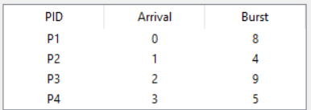

Round Robin
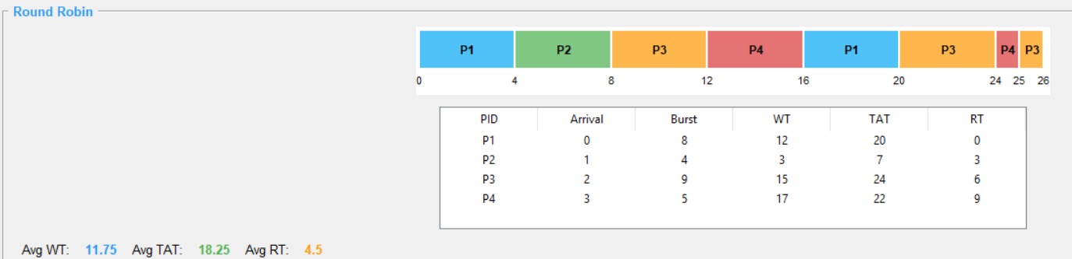

SRTF
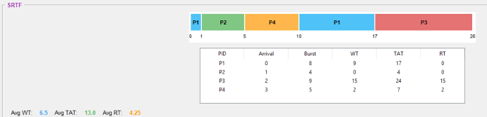

Comparison Summary & Conclusion
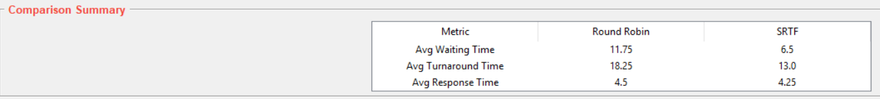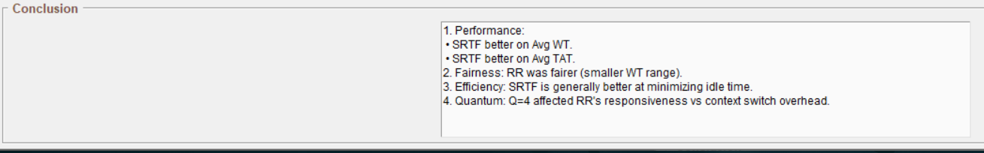

Quantum Sensitivity Case

Write-up
We Entered two different time quantum (small, big ) to highlighting the big difference in RR Algorithm.

Processes & Ready Queue
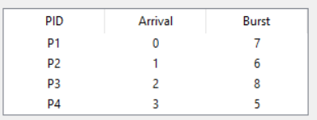
  - With Q = 2
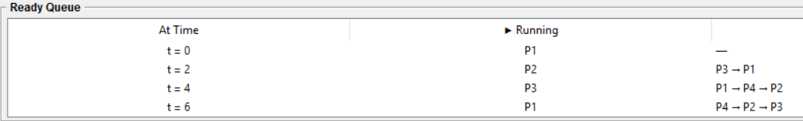
  - With Q = 8
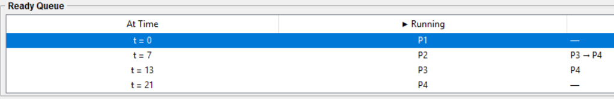

Round Robin
  - With Q = 2
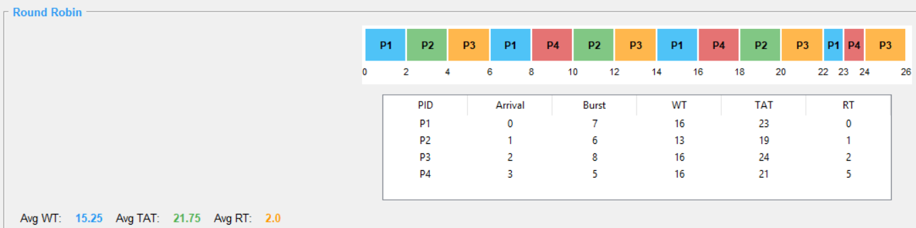
  - With Q = 8
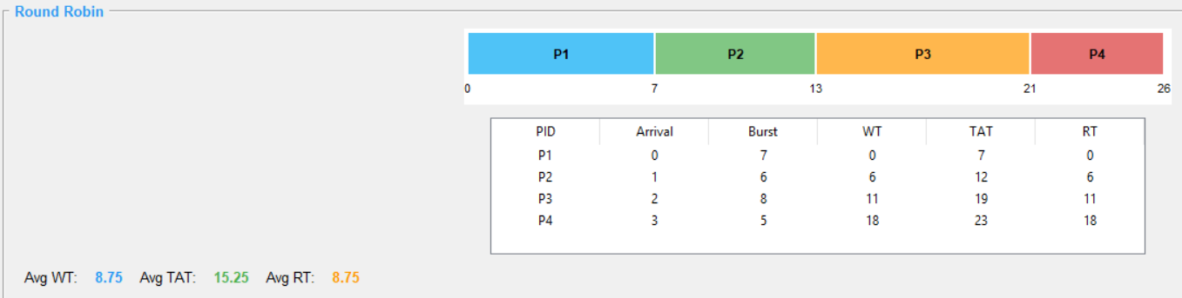

SRTF

No difference.
  - With Q = 2
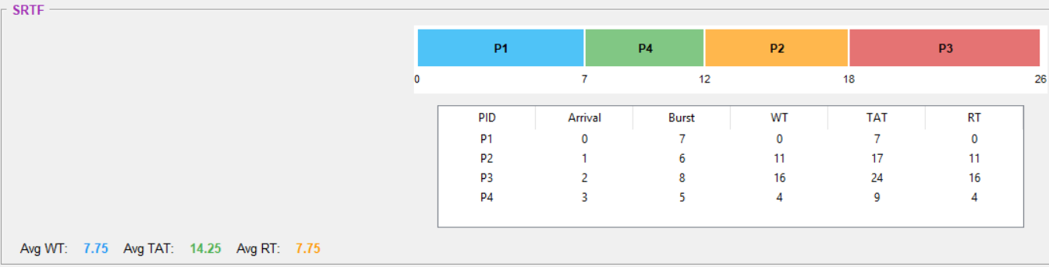
  - With Q = 8
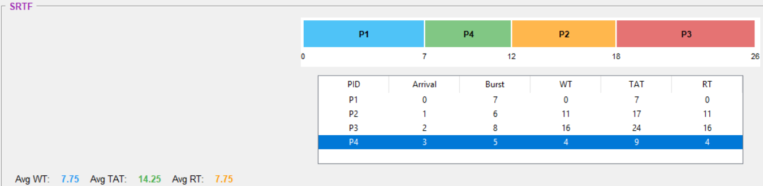

Comparison Summary & Conclusion
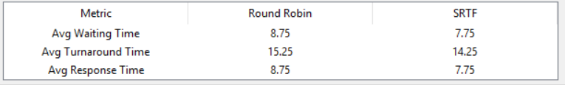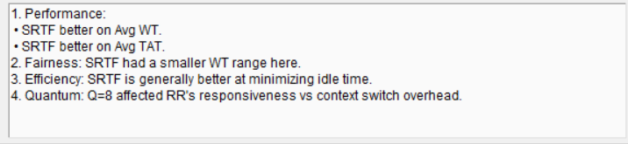

Short-job-heavy case

Write-up
We Entered a one heavy process with a lot of short processes to highlighting SRTF Algorithm Work Way.

Processes & Ready Queue
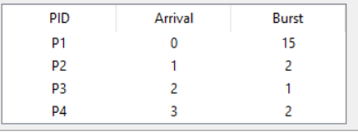
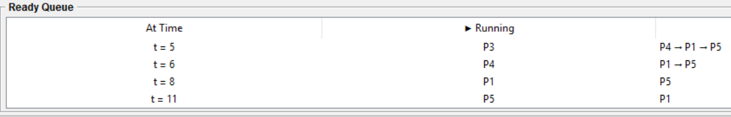

Round Robin
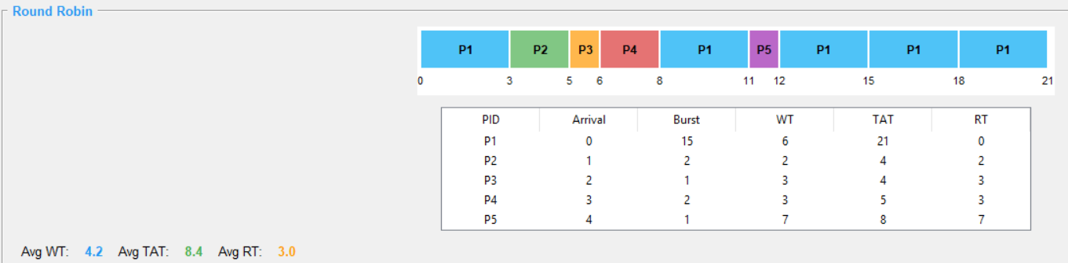

SRTF
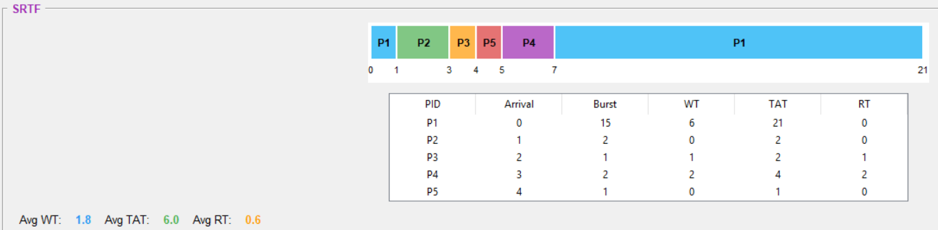

Comparison Summary & Conclusion
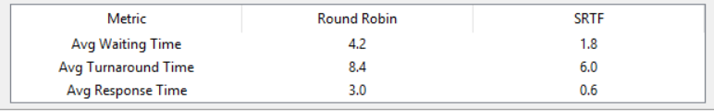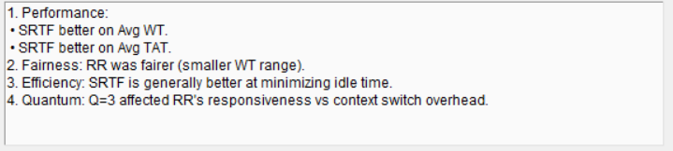

Interactive-style fairness case

Write-up
We Entered a processes that Is have a time numbers close to each other with same arrival time to highlighting difference between SRTF & RR Algorithms.

Processes & Ready Queue
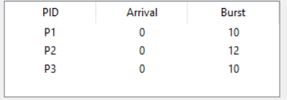
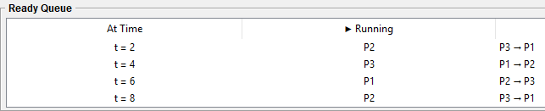

Round Robin
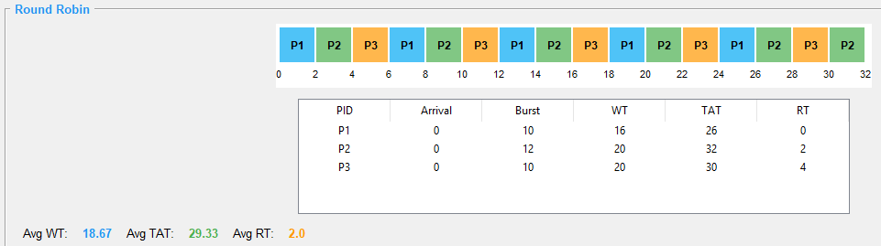

SRTF
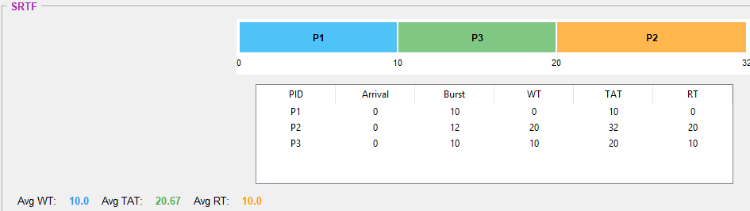

Comparison Summary & Conclusion
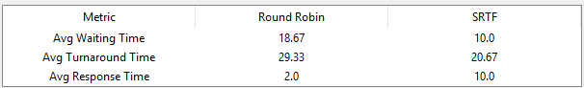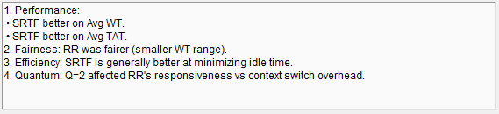

Validation case

Write-up
We Entered more than invalid inputs to check the system validation.

Wrong ID Number
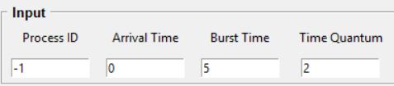
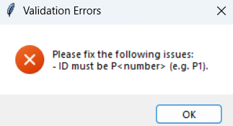

Duplicate Process ID
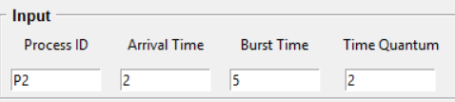
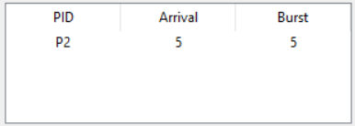
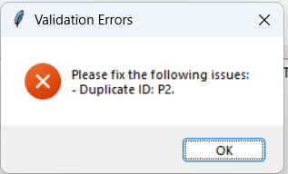

Wrong Arrival Time
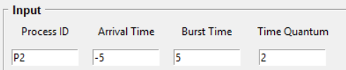
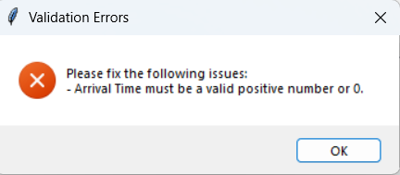

Wrong Burst Time
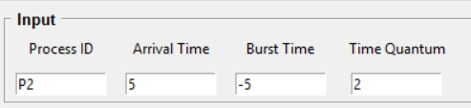
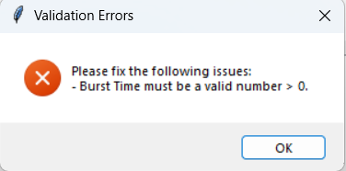

Wrong Quantum Time
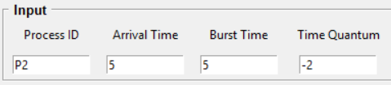
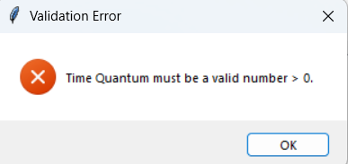

Run With 0 Processes



Required Analysis Questions

SRTF is better in Waiting time
SRTF finishing the small processes first, that leads to decreasing the processes number means small Waiting time

RR is better in Response time
RR give all processes small response time based on it work way ( Q slicing ) .

RR is fairer with all processes
RR is always fair based on it work way ( Q slicing ) .

SRTF Complete short jobs faster
SRTF work way build on complete the smallest processes in first.

Q affect RR results in this way
  - Small Q leads to more fair and good response time but increase the context switch times and that’s leads to led to an increase in turnaround time.
  - Large Q leads to less context switch times ( decreasing in turnaround time ) but that leads to unfair & increasing in response time.

I Recommended
RR: if our goal is the fairness and if we build interactive system.
SRTF: if the system processes is always small and if we targeting the Average ( WT, TAT ).

